1. By default, @Transactional rolled back transaction only for Unchecked exceptions (Means Runtime Exceptions) and error.
2. 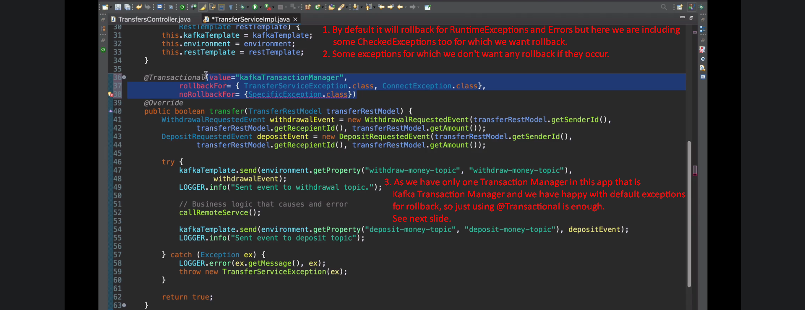
3. 